***Adding Animation to Websites***

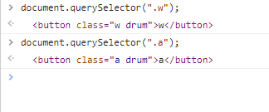

**Window setTimeout()**

**Definition and Usage**

The setTimeout() method calls a function after a number of milliseconds.

1 second = 1000 milliseconds.

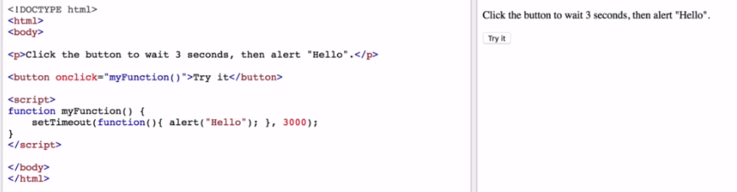

<https://www.w3schools.com/jsref/met_win_settimeout.asp>

**Syntax:**

setTimeout(function, milliseconds, param1, param2, ...);

Search **JavaScript Animations**

<https://www.w3schools.com/js/js_htmldom_animate.asp>

<https://www.w3schools.com/howto/howto_js_animate.asp>

<https://developer.mozilla.org/en-US/docs/Web/API/Element/animate>

***Code:***

**Index4.html:**

<!DOCTYPE html>

<html lang="en" dir="ltr">

<head>

<meta charset="utf-8">

<title>Drum Kit Sounds</title>

<link rel="stylesheet" href="styles4.css">

<link href="https://fonts.googleapis.com/css2?family=Arvo" rel="stylesheet">

</head>

<body>

<h1>Drum 🥁 Kit</h1>

<div class="Set">

<button class="w drum">w</button>

<button class="a drum">a</button>

<button class="s drum">s</button>

<button class="d drum">d</button>

<button class="j drum">j</button>

<button class="k drum">k</button>

<button class="l drum">l</button>

</div>

<script src="index4.js" charset="utf-8"></script>

</body>

<footer class="footer">

Made with ❤️ in London.

</footer>

</html>

**Index4.js:**

//Detecting Button Press

var noOfDrumButtons = document.querySelectorAll(".drum").length;

for (var i = 0; i < noOfDrumButtons; i++) {

//W button

document.querySelectorAll(".drum")[i].addEventListener("click", function() {

var buttonInnerHTML = this.innerHTML;

makeSound(buttonInnerHTML);

//Add Annimations

buttonAnnimation(buttonInnerHTML);

});

}

//Let's add keyboard functionality

/*

document.addEventListener("keypress", function(){

alert("Key was pressed");

});

*/

//Detecting Keyboard Press

document.addEventListener("keypress", function(event){

// alert("Key was pressed");

makeSound(event.key);

//Add Annimations

buttonAnnimation(event.key);

});

//Let's make sound

function makeSound(key){

switch (key) {

case "w":

var audio = new Audio("sounds/dr-tom.mp3");

audio.play();

break;

case "a":

var crash = new Audio("sounds/crash.mp3");

crash.play();

break;

case "s":

var kick = new Audio("sounds/kick.mp3");

kick.play();

break;

case "d":

var audio = new Audio("sounds/smooth-beat.mp3");

audio.play();

break;

case "j":

var audio = new Audio("sounds/tom1.mp3");

audio.play();

break;

case "k":

var audio = new Audio("sounds/tom2.mp3");

audio.play();

break;

case "l":

var audio = new Audio("sounds/tom3.mp3");

audio.play();

break;

default:

console.log(buttonInnerHTML);

}

}

//Let's add Annimations

function buttonAnnimation(currentKey){

var activeButton = document.querySelector("." + currentKey);

activeButton.classList.add('pressed');

setTimeout(function(){

activeButton.classList.remove("pressed");

},100); //Remove annimation after 100 miliseconds

}

**Styles4.css:**

body{

background-color: #483D8B;

text-align: center;

color: #fff;

font-family: "swap", Arvo;

}

h1{

text-align: center;

/* color: #fff; */

font-size: 5rem;

padding-bottom: 5%;

}

.Set{

margin: 10% auto;

}

.pressed{

box-shadow: 0 3px 4px 0 #DBEDF3;

opacity: 0.5;

}

.red{

color: red;

}

.footer{

padding-top: 7%;

}

.drum{

padding: 2% 3%;

margin: 1%;

border-radius: 15%;

border: solid 10px;

border-color: #6A5ACD;

font-size: 2rem;

font-weight: bold;

color: #C71585;

font-family: 'Arvo', cursive;

}

/* Add background images to each button*/

.w{

background-image: url('images/title.jpg');

}

.a{

background-image: url("images/kick-drum.png");

background-size: contain;

}

.s{

background-image: url('images/crash-drum.png');

background-size: contain;

}

.d{

background-image: url("images/music1.jpg");

background-size: contain;

}

.j{

background-image: url("images/music2.jpg");

background-size: cover;

}

.k{

background-image: url("images/music3.jpg");

background-size: contain;

}

.l{

background-image: url("images/music4.jpg");

background-size: contain;

}